Execution Steps

Execution was performed by executing the Oracle Procedure “CDW_DATA_TRANSFER.PULL_LATEST_LABS” from within SQL*Plus. This would mimic the execution of the 6:00am automated procedure.

The process finished successfully. The next step is to examine the execution and output results log files from the Oracle Clinical Batch File load process. Both of these files showed no abnormalities.

The final step included queries against the raw data stored in the Oracle table BDL_TEMP_FILES against the actual data displayed by Oracle Clinical.

Lab Load Spool File
This file was created to echo process and results encountered during execution.

SQL> select distinct patient_id, oc_study, substr(error_reason,1,30)
2 , substr(labtest_name,1,30)
3 from nci_labs
4 where load_flag = 'N';

no rows selected

SQL> select load_flag, count(*) from nci_labs group by load_flag;

L COUNT(*)
- ----------
C 8638
D 1
E 3785
X 6

SQL> set serveroutput on 1000000
SQL> set buffer 1000000
SQL> exec cdw_data_transfer.pull_latest_labs
OS File is open.
Process Job Id = 5261
Log File = /export/home/bdl/log/l5261.log
Out File = /export/home/bdl/log/o5261.out
OS File Id = 29501
CMD = rxcbeblt "-1/export/home/bdl/log/o5261.out" "-2-1" "-3-1" "-45" "-5/"
"-629501" "-73" "-820" "-9300" "-10Y" "-11/export/home/opapps/bdl" "-12Y"

PL/SQL procedure successfully completed.

SQL>
SQL> select distinct patient_id, oc_study, substr(error_reason,1,30)
2 , substr(labtest_name,1,30)
3 from nci_labs
4 where load_flag = 'N';

no rows selected

SQL> select load_flag, count(*) from nci_labs group by load_flag;

L COUNT(*)
- ----------
C 8702
D 1
E 3798
X 6

SQL> select COUNT(*) from bdl_temp_files;

COUNT(*)
----------
590

SQL> desc bdl_temp_files;
Name Null? Type
----------------------------------------- -------- ----------------------------
ID VARCHAR2(20)
INVESTIGATOR VARCHAR2(10)
SITE VARCHAR2(10)
PATIENT VARCHAR2(10)
DOCUMENT_NO VARCHAR2(20)
PLANNED_EVENT VARCHAR2(30)
SUBEVENT_NO NUMBER(2)
DCI_DATE VARCHAR2(50)
DCI_TIME VARCHAR2(6)
DCI_NAME VARCHAR2(50)
DCM_NAME VARCHAR2(50)
DCM_SUBSET VARCHAR2(50)
DCM_QUESGRP VARCHAR2(50)
DCM_QUES VARCHAR2(50)
DCM_OCCUR NUMBER(3)
REPEAT_SN NUMBER(4)
VALUETEXT VARCHAR2(200)
DATA_COMMENT VARCHAR2(200)
QUALIFYING_VALUE VARCHAR2(100)
STUDY VARCHAR2(50)
DATE_CREATED DATE
DATE_MODIFIED DATE
CREATED_BY VARCHAR2(240)
MODIFIED_BY VARCHAR2(240)

SQL> set linesize 200
SQL> set pagesize 200
SQL> select PATIENT, STUDY, DCI_NAME, DCM_NAME from bdl_temp_files;

…
Note: Some output remove for sizing purposes
…

1 select PATIENT, STUDY, DCI_NAME, DCM_NAME, VALUETEXT from bdl_temp_files
2* WHERE patient='10'
SQL> /

PATIENT STUDY DCI_NAME DCM_NAME
---------- -------------------------------------------------- -------------------------------------------------- --------------------------------------------------
VALUETEXT
--------------------------------------------------------------------------------------------------------------------------------------------------------------------------------------------------------
10 NCI5319 RED CELL INDICES LAB_RC
79.0-98.0

10 NCI5319 RED CELL INDICES LAB_RC

10 NCI5319 RED CELL INDICES LAB_RC

10 NCI5319 RED CELL INDICES LAB_RC
MCH

10 NCI5319 RED CELL INDICES LAB_RC
MCHC

10 NCI5319 RED CELL INDICES LAB_RC
BLEEDING_TIME

10 NCI5319 RED CELL INDICES LAB_RC
CLOT_RETRACTION_SCR

10 NCI5319 RED CELL INDICES LAB_RC
SEMI_QUANT

10 NCI5319 RED CELL INDICES LAB_RC
QUANTITIVE

10 NCI5319 RED CELL INDICES LAB_RC
CLOTTING_TIME

10 NCI5319 RED CELL INDICES LAB_RC
FDP

10 NCI5319 RED CELL INDICES LAB_RC
FIBRINOGEN

10 NCI5319 RED CELL INDICES LAB_RC
THROMBIN_TIME

…
Note: More output remove for sizing purposes
…

10 NCI5319 BLOOD CHEMISTRY LAB_BC
mmol/L

10 NCI5319 BLOOD CHEMISTRY LAB_BC
508292

10 NCI5319 BLOOD CHEMISTRY LAB_BC
CDW

10 NCI5319 BLOOD CHEMISTRY LAB_BC
2.05-2.50

10 NCI5319 BLOOD CHEMISTRY LAB_BC

10 NCI5319 BLOOD CHEMISTRY LAB_BC

10 NCI5319 BLOOD CHEMISTRY LAB_BC
CHLORIDE

10 NCI5319 BLOOD CHEMISTRY LAB_BC
104

10 NCI5319 BLOOD CHEMISTRY LAB_BC
mmol/L

10 NCI5319 BLOOD CHEMISTRY LAB_BC
508297

10 NCI5319 BLOOD CHEMISTRY LAB_BC
CDW

10 NCI5319 BLOOD CHEMISTRY LAB_BC
99-107

10 NCI5319 BLOOD CHEMISTRY LAB_BC

PATIENT STUDY DCI_NAME DCM_NAME
---------- -------------------------------------------------- -------------------------------------------------- --------------------------------------------------
VALUETEXT
--------------------------------------------------------------------------------------------------------------------------------------------------------------------------------------------------------
10 NCI5319 BLOOD CHEMISTRY LAB_BC

10 NCI5319 BLOOD CHEMISTRY LAB_BC
ALBUMIN_SERUM

10 NCI5319 BLOOD CHEMISTRY LAB_BC
2.8

303 rows selected.

SQL> l
1 select PATIENT, STUDY, DCI_NAME, DCM_NAME, VALUETEXT from bdl_temp_files
2* WHERE patient='10'
SQL> spool off

Log File of Oracle Clinical Batch Load
This file is the log file of the execution of a lab data load.

Found line in oratab file for database "CTDEV".
Code env "40" found in opa_settings for database "CTDEV".
Database "CTDEV" found in oratab.
Setting ORACLE_HOME and ORACLE_SID for local database "CTDEV"
Setting RXC_ROOT
...Done.
LOGNAME=bdl
Connected to database.
Job started.
Starting 3GL command...
OS User=bdl
Exit status of 3GL=0, Pid=23924
Completed with SUCCESS status.

Output File of Oracle Clinical Batch Load
This file is the log file of the execution of a lab data load.

------------------------------------------------------
database charset = US7ASCII.
local language = ENGLISH.
copy is required = YES.
copy indicator = ~.
------------------------------------------------------
***************************************
OS File ------- LOAD_DLM_LABS
OS File Name ---- /tmp/labt_0520.dat
Mask ID - 2001
***************************************
Out of Study Load started at Tue May 20 11:54:57 2003

CHARACTER SET = SINGLE_BYTE

------------------------------------------------------
need to convert = 0.
in file charset = SINGLE_BYTE.
out file charset = SINGLE_BYTE.
------------------------------------------------------
590 out of 590 records from data file (/tmp/labt_0520.dat)
have been inserted into Temporary Batch Data Items table.
Out of Study Load ended at Tue May 20 11:55:06 2003

Updating os file.
Out of Study Load has been completed successfully.

***************************************
Study ------- NCI5319
Data File ------- LOAD_DLM_LABS_NCI5319_FILE_0
OS File Name ---- Not Applicable - OOS
DF Creation TS - 20-MAY-03 11:54:57
Mask ID - 2001
***************************************
Prepare started at Tue May 20 11:55:06 2003

Setting roll back segment if any specified

Warning: The following questions are in the DCM but are missing
in Data File.

NOTE
NOTE_DT

Prepare ended at Tue May 20 11:55:07 2003

Number of prospective DCI inserts = 2
Number of prospective DCI updates = 0
Updating Data_Files with Status: PREPARED

Transfer started at Tue May 20 11:55:07 2003

-------------------------------------
study NCI5319 is NOT NLS enabled.

-------------------------------------
CHARACTER SET = SINGLE_BYTE

------------------------------------------------------
need to convert = 0.
in file charset = SINGLE_BYTE.
out file charset = SINGLE_BYTE.
------------------------------------------------------

-------------------------------------
study NCI5319 is NOT NLS enabled.

-------------------------------------

-------------------------------------
study NCI5319 is NOT NLS enabled.

-------------------------------------

-------------------------------------
study NCI5319 is NOT NLS enabled.

-------------------------------------

-------------------------------------
study NCI5319 is NOT NLS enabled.

-------------------------------------

-------------------------------------
study NCI5319 is NOT NLS enabled.

-------------------------------------

-------------------------------------
study NCI5319 is NOT NLS enabled.

-------------------------------------
Updating data file status
Warning: No updates pending or bad updates had been performed previously.
Transfer ended at Tue May 20 11:55:08 2003

Number of inserts made in Received DCIs: 2
Number of inserts made in Received DCMs: 2
Number of inserts made in Responses: 550
Number of inserts made in Discrepancy Entries: 0
Number of updates made in Received DCIs: 0
Number of updates made in Received DCMs: 0
Number of updates made in Responses: 0
Number of updates made in Discrepancy Entries: 0

Transfer has been completed successfully.
***************************************
Study ------- NCI5319
Data File ------- LOAD_DLM_LABS_NCI5319_FILE_1
OS File Name ---- Not Applicable - OOS
DF Creation TS - 20-MAY-03 11:55:02
Mask ID - 2001
***************************************
Prepare started at Tue May 20 11:55:08 2003

Setting roll back segment if any specified

Warning: The following questions are in the DCM but are missing
in Data File.

NOTE
NOTE_DT

Prepare ended at Tue May 20 11:55:08 2003

Number of prospective DCI inserts = 2
Number of prospective DCI updates = 0
Updating Data_Files with Status: PREPARED

Transfer started at Tue May 20 11:55:08 2003

-------------------------------------
study NCI5319 is NOT NLS enabled.

-------------------------------------
CHARACTER SET = SINGLE_BYTE

------------------------------------------------------
need to convert = 0.
in file charset = SINGLE_BYTE.
out file charset = SINGLE_BYTE.
------------------------------------------------------

-------------------------------------
study NCI5319 is NOT NLS enabled.

-------------------------------------

-------------------------------------
study NCI5319 is NOT NLS enabled.

-------------------------------------

-------------------------------------
study NCI5319 is NOT NLS enabled.

-------------------------------------

-------------------------------------
study NCI5319 is NOT NLS enabled.

-------------------------------------

-------------------------------------
study NCI5319 is NOT NLS enabled.

-------------------------------------
Updating data file status
Warning: No updates pending or bad updates had been performed previously.
Transfer ended at Tue May 20 11:55:09 2003

Number of inserts made in Received DCIs: 2
Number of inserts made in Received DCMs: 2
Number of inserts made in Responses: 418
Number of inserts made in Discrepancy Entries: 8
Number of updates made in Received DCIs: 0
Number of updates made in Received DCMs: 0
Number of updates made in Responses: 0
Number of updates made in Discrepancy Entries: 0

Transfer has been completed successfully.
***************************************
Study ------- NCI5319
Data File ------- LOAD_DLM_LABS_NCI5319_FILE_2
OS File Name ---- Not Applicable - OOS
DF Creation TS - 20-MAY-03 11:55:05
Mask ID - 2001
***************************************
Prepare started at Tue May 20 11:55:09 2003

Setting roll back segment if any specified

Warning: The following questions are in the DCM but are missing
in Data File.

NOTE
NOTE_DT

Prepare ended at Tue May 20 11:55:09 2003

Number of prospective DCI inserts = 2
Number of prospective DCI updates = 0
Updating Data_Files with Status: PREPARED

Transfer started at Tue May 20 11:55:09 2003

-------------------------------------
study NCI5319 is NOT NLS enabled.

-------------------------------------
CHARACTER SET = SINGLE_BYTE

------------------------------------------------------
need to convert = 0.
in file charset = SINGLE_BYTE.
out file charset = SINGLE_BYTE.
------------------------------------------------------

-------------------------------------
study NCI5319 is NOT NLS enabled.

-------------------------------------

-------------------------------------
study NCI5319 is NOT NLS enabled.

-------------------------------------

-------------------------------------
study NCI5319 is NOT NLS enabled.

-------------------------------------

-------------------------------------

study NCI5319 is NOT NLS enabled.

-------------------------------------

-------------------------------------
study NCI5319 is NOT NLS enabled.

-------------------------------------
Updating data file status
Warning: No updates pending or bad updates had been performed previously.
Transfer ended at Tue May 20 11:55:10 2003

Number of inserts made in Received DCIs: 2
Number of inserts made in Received DCMs: 2
Number of inserts made in Responses: 462
Number of inserts made in Discrepancy Entries: 0
Number of updates made in Received DCIs: 0
Number of updates made in Received DCMs: 0
Number of updates made in Responses: 0
Number of updates made in Discrepancy Entries: 0

Transfer has been completed successfully.
***************************************
Study ------- NCI5319
Data File ------- LOAD_DLM_LABS_NCI5319_FILE_3
OS File Name ---- Not Applicable - OOS
DF Creation TS - 20-MAY-03 11:55:06
Mask ID - 2001
***************************************
Prepare started at Tue May 20 11:55:10 2003

Setting roll back segment if any specified

Warning: The following questions are in the DCM but are missing
in Data File.

NOTE
NOTE_DT

Prepare ended at Tue May 20 11:55:10 2003

Number of prospective DCI inserts = 1
Number of prospective DCI updates = 0
Updating Data_Files with Status: PREPARED

Transfer started at Tue May 20 11:55:10 2003

-------------------------------------
study NCI5319 is NOT NLS enabled.

-------------------------------------
CHARACTER SET = SINGLE_BYTE

------------------------------------------------------
need to convert = 0.
in file charset = SINGLE_BYTE.
out file charset = SINGLE_BYTE.
------------------------------------------------------

-------------------------------------
study NCI5319 is NOT NLS enabled.

-------------------------------------

-------------------------------------
study NCI5319 is NOT NLS enabled.

-------------------------------------
Updating data file status
Warning: No updates pending or bad updates had been performed previously.
Transfer ended at Tue May 20 11:55:10 2003

Number of inserts made in Received DCIs: 1
Number of inserts made in Received DCMs: 1

Number of inserts made in Responses: 132
Number of inserts made in Discrepancy Entries: 1
Number of updates made in Received DCIs: 0
Number of updates made in Received DCMs: 0
Number of updates made in Responses: 0
Number of updates made in Discrepancy Entries: 0

Transfer has been completed successfully.

Screen Shot of Loaded Patient Data
This screen shot shows the data that was loaded.

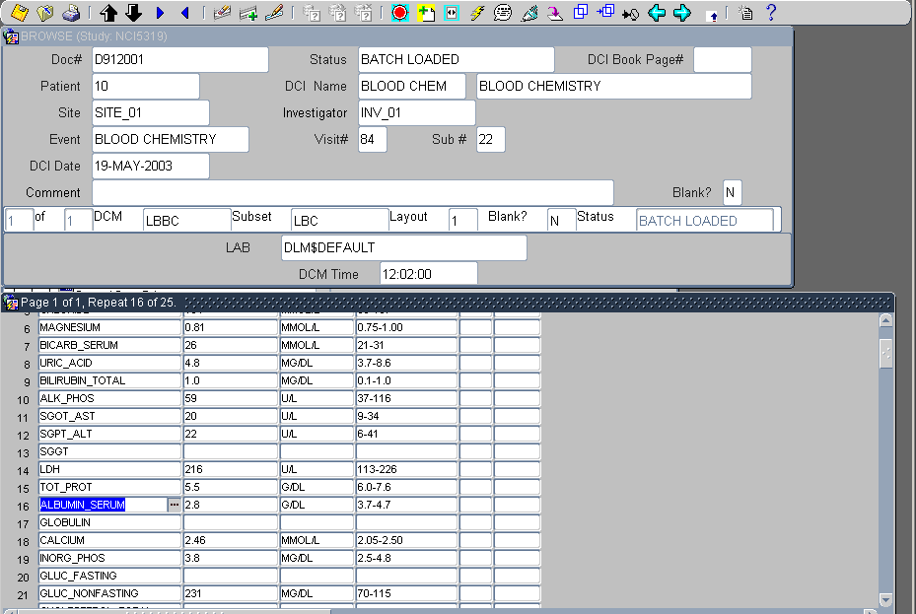
Screen Shot of Batch Load Results
This screen shot shows Batch Data Load Results

